**ALAGAPPA COLLEGE OF TECHNOLOGY**

**ANNA UNIVERSITY-600025**

**PROJECT REPORT**

**BRAND LOGO**

|  |  |
| --- | --- |
| **Date** | 26 October 2023 |
| **Team Lead** | Kavya P  (2020304009)  ID : 6ACEEEB6C5C2352A41D411ABEE4F8E14 |
| **Team Member 1** | Rithika G  (2020304019)  ID : 2C122D7C3892909B9044E817FA3DE548 |
| **Team Member 2** | Sruthi S  (2020304027)  ID : 1D0D3F7DF709FA98C354A2EBF12D9DC3 |
| **Team Member 3** | Sruthika K  (2020304028)  ID : AFA0BD324BCAEA2B89C4B265661004B0 |
| **Project Name** | Brand Logo |

**INTRODUCTION**

Overview

Creation of Brand logo and email id as a part of Naan Mudhalvan curriculum.

Purpose

Captivating the youngsters by providing well planned trekking experience.

**PROBLEM DEFINITION & DESIGN THINKING**

Brand Name Creation: Create a brand name, Brand identity Design: Design a brand logo - using Canva and Create an email account on Gmail to link all your project work - (brandname@gmail.com), use this email account centrally to access all tools and platforms by signing up with the created gmail id

**RESULT**

Brand Name: Zestrek

Category: Tourism

Target Audience: Youngsters ( Men & Women)

Email : zestrektourism@gmail.com

Logo Theme : Tourism – Trekking

File upload – PNG , PDF of brand logo

Document – with attached screenshots with steps

Video – steps to create a brand logo and an E-mail ID in Gmail

**CREATING BRAND LOGO**

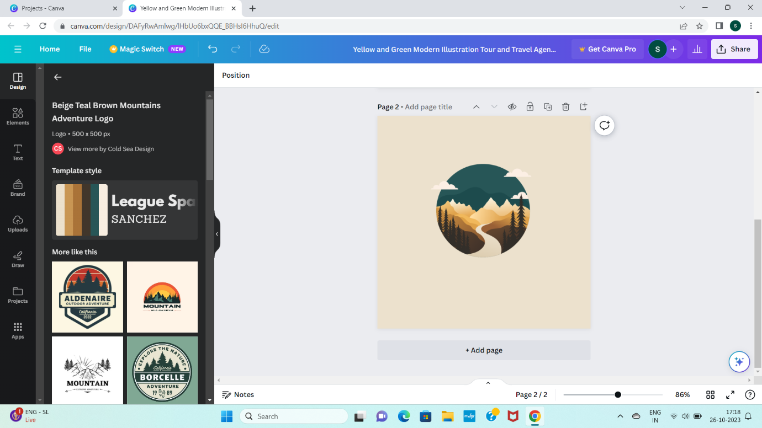

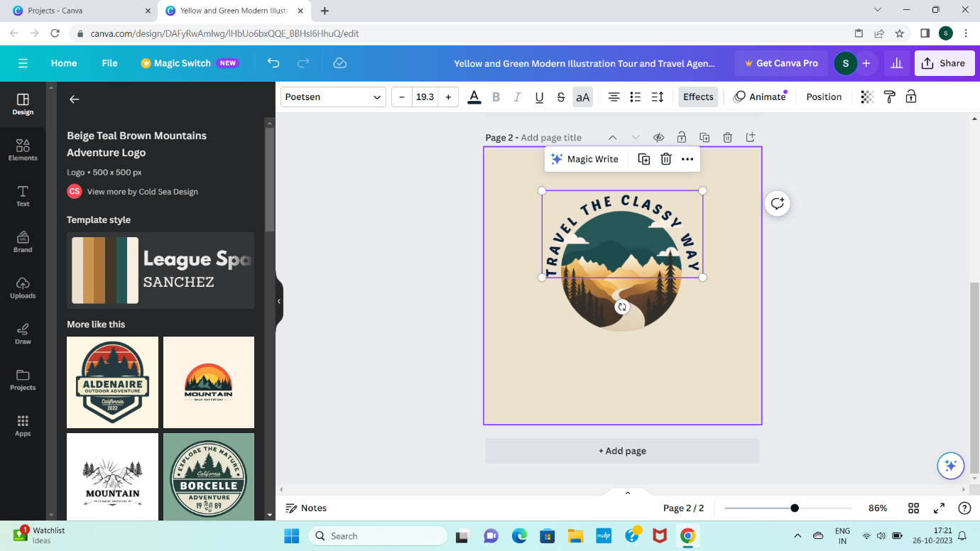

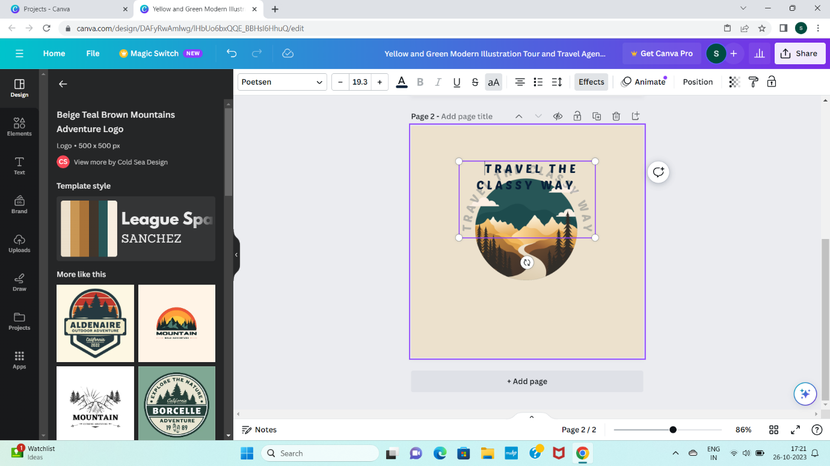

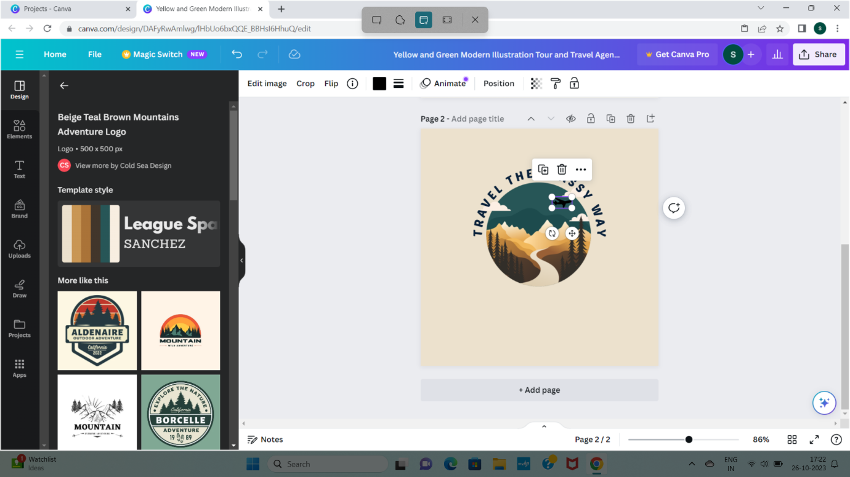

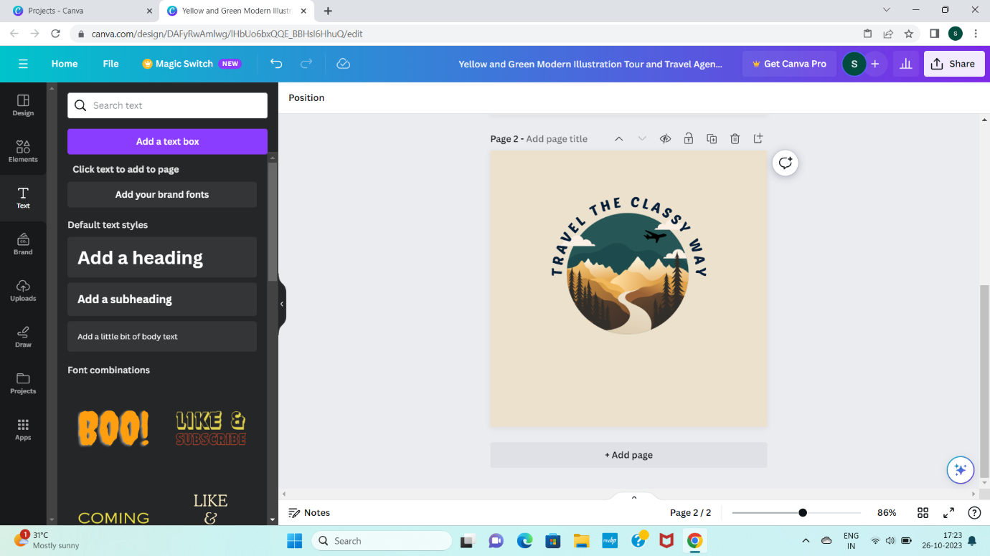

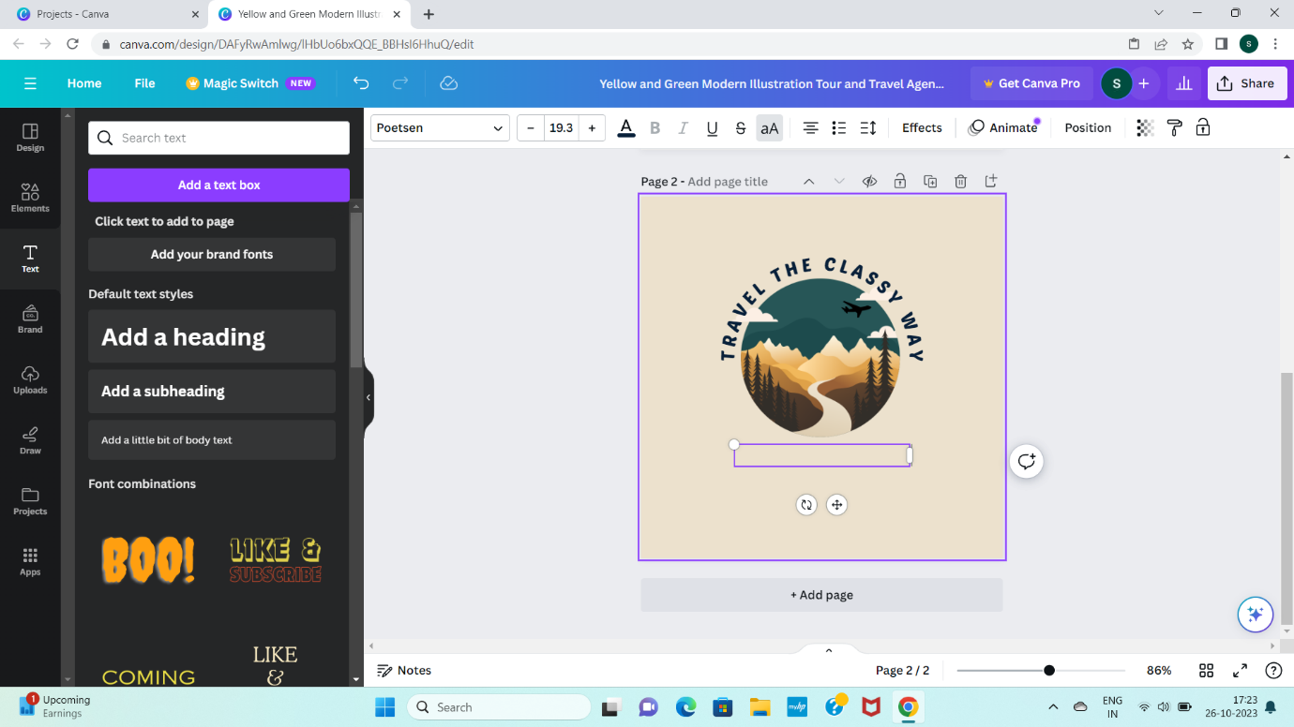

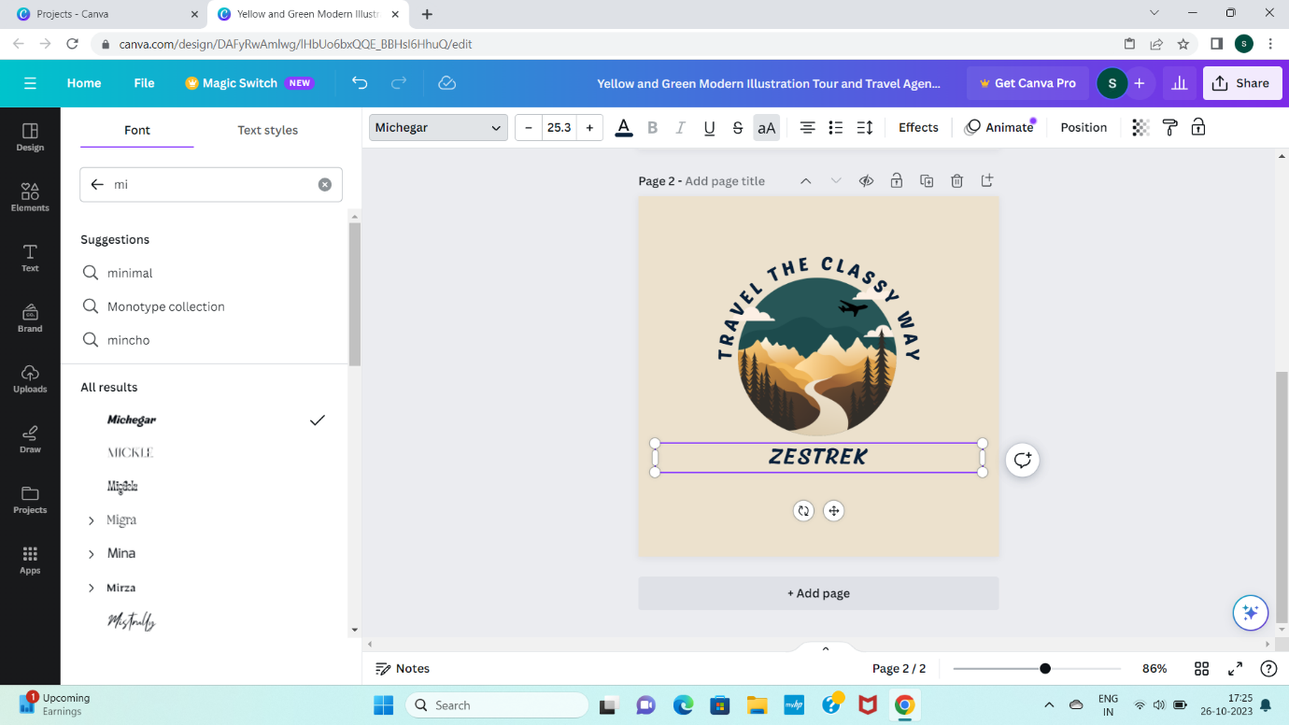

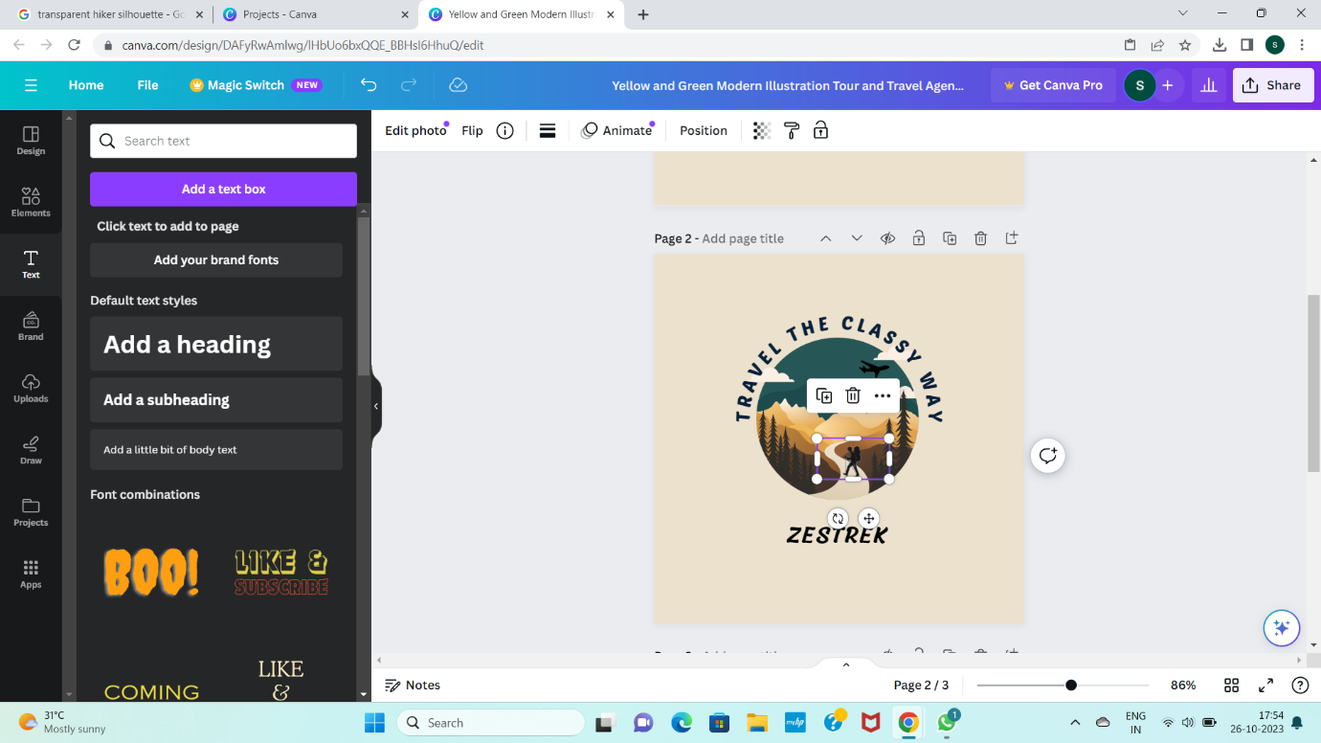

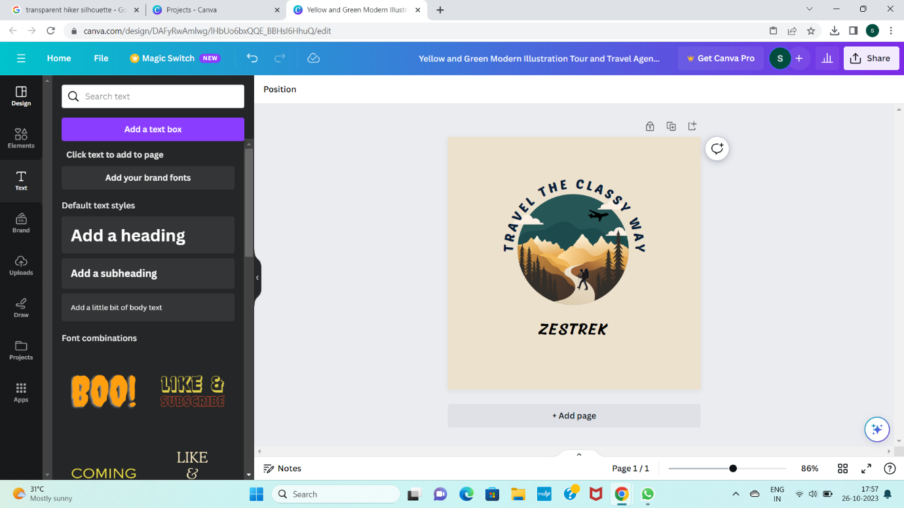

**CREATING EMAIL ID**

1. Log into email

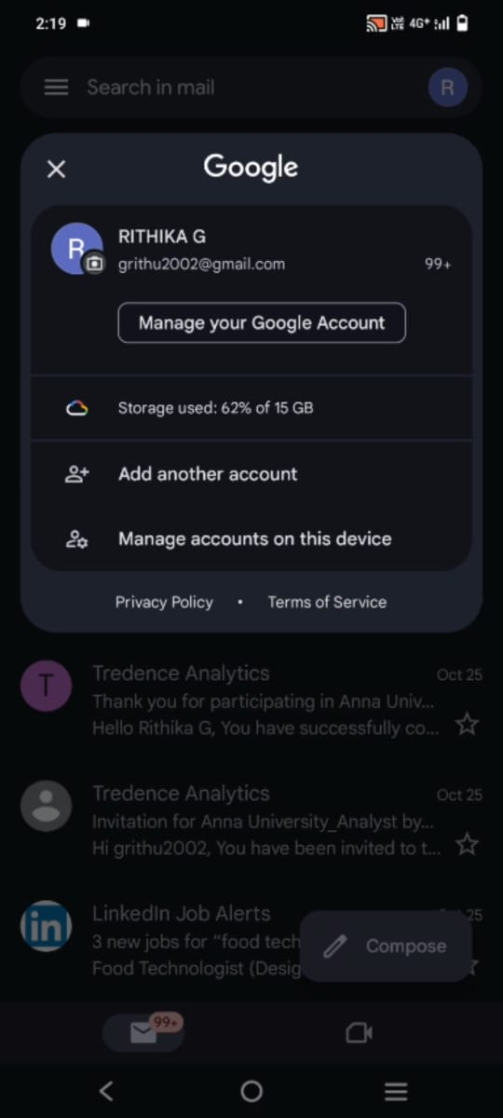

1. Set up email

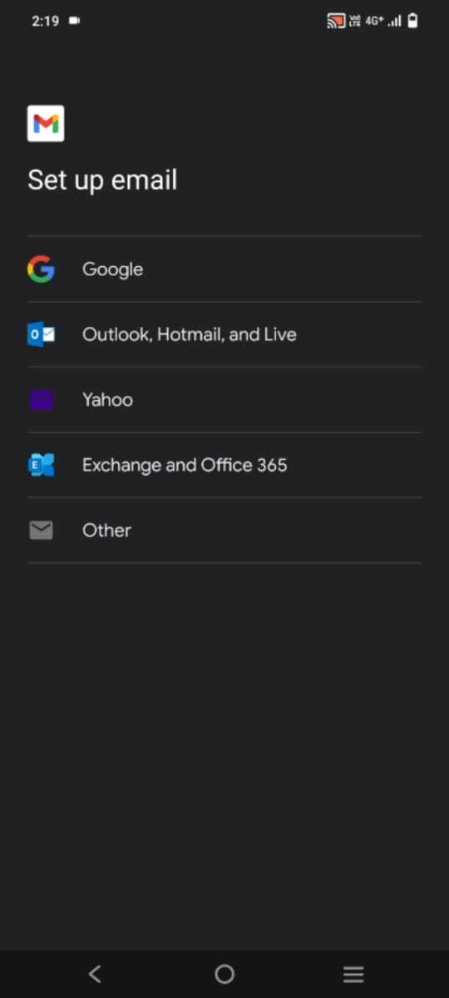

1. Create an account

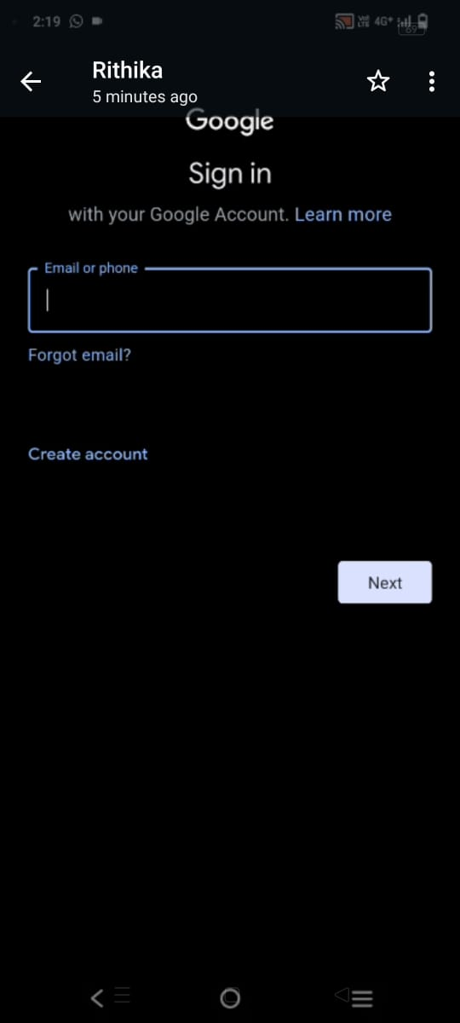

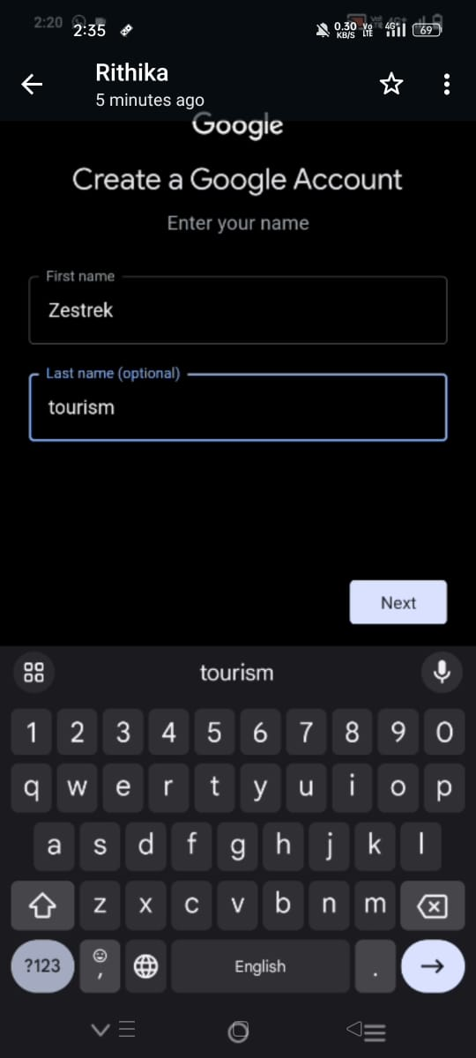

1. Fill Basic Information

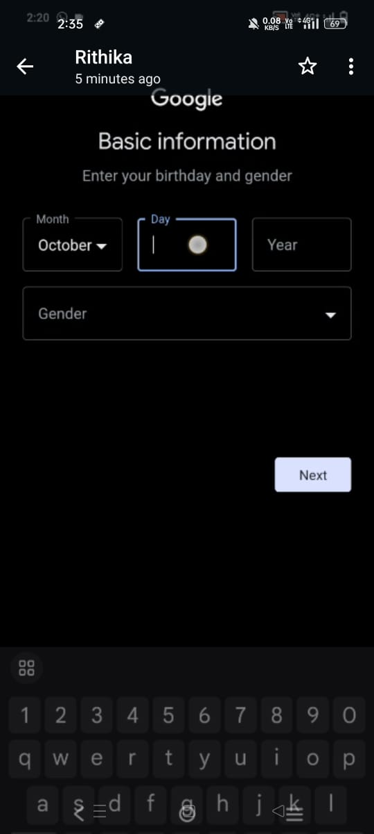

1. Choose your Gmail Address

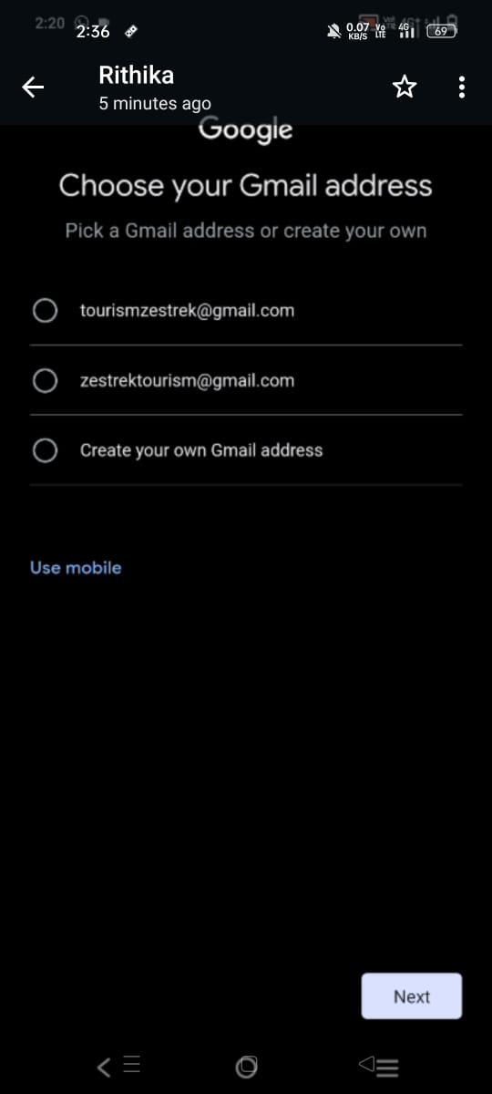

1. Create Password

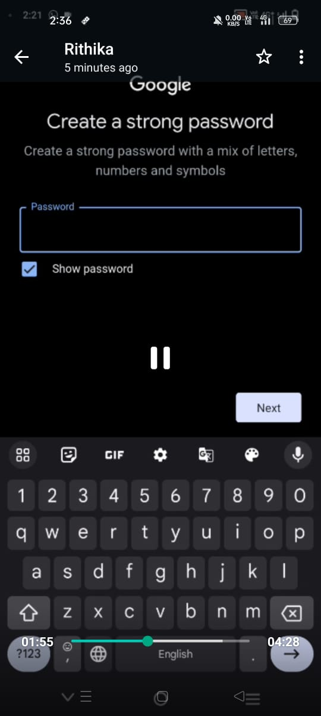

1. Review your account info

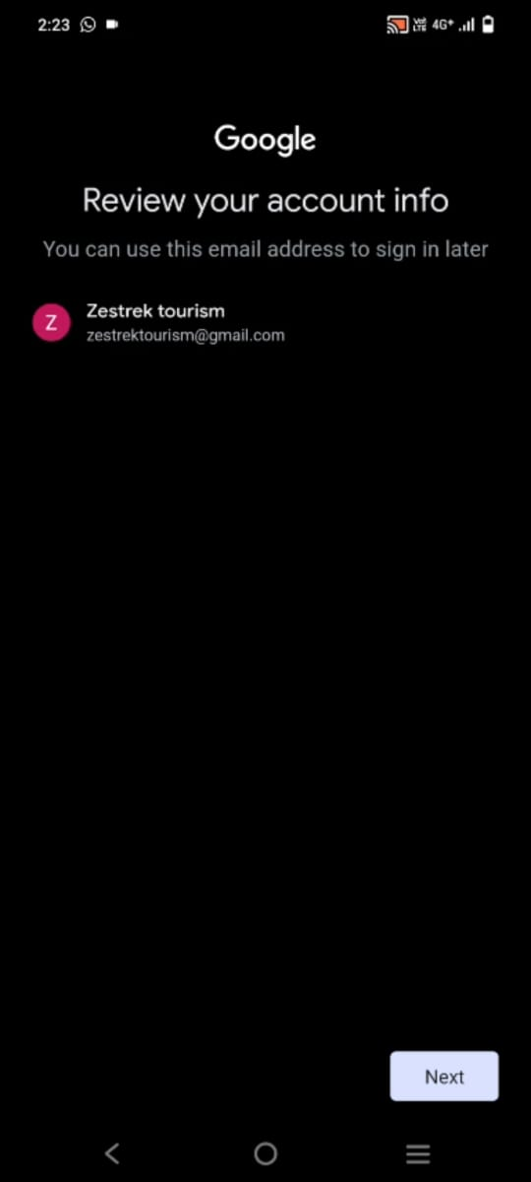

1. Agree to terms and conditions

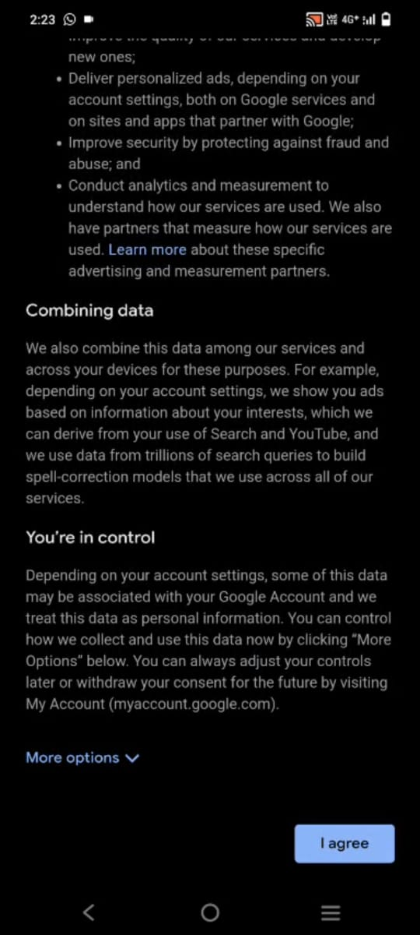

**APPLICATIONS**

Brand logo is used in digital marketing by featuring it on websites, social media profiles, email signatures, and online advertisements.

**CONCLUSION**

A brand logo has been created for the brand and an email ID has also been created.